Personal Branding Assignment
By Amna Chaudhary
99386157
Sheridan College, HMC Campus
Professor Dr Khalil Rohani
March 7, 2017

- Mission Statement
On a journey to be successful leader whilst accepting and learning from my mistakes, to live a balanced life and never loose my morals and values because they define me.
- Self Analysis - SWOT

Strengths  - Strong communication skills  - Great team leader and team building skills  - Innovative and creative  - My flexibility and commitment I can provide as I have no dependents or a family to look after  - Positive attitude which allows me to make strong and long lasting contacts | Weaknesses  - Occasionally, when handling multiple tasks at a time can be overwhelming but has never stopped me from meeting deadlines  - Stage freight can arise sometimes when presenting in class  - Need constant reassurance from managers about my accomplished tasks for motivation  - Lack of work experience in the specific field of HR
Opportunities  - Showing interest and motivation to move ahead in the organization  - Strong networking and positive relations with management  - More than 3 years of experience in retail  - CHRP membership for creating a network and find prospects who can assist me in finding a job in HR | Threats  - Students graduating with me will act as a threat to me when applying for jobs  - External hiring within the organization I am currently employed under  - Little network established in the Human resource field  - A candidate with CHRP designation applying for the same job as me, where I am just beginning to pursue it

- Career objectives

My 1st objective is to graduate by 2018 with the Bachelor of Human Resources from Sheridan College.
My 2nd objective is to look for a job by the end of 2017 to make sure I am financially secure when I graduate and start paying off my OSAP.
My 3rd objective is to give my first CHRP Exam by summer 2018 as this will enable me to create a network with people in my field of interest and create connections.

- Dream job and dream employer

TJX Canada is commonly known by the names of Winners, Home Sense, or Marshalls which are retail shops carrying the latest designer wear or household items for low prices. The main goal of the company is to provide the best price for designer names. The current rank of TJX in Fortune 500 listing is 89 and they are continuing to succeed which was evident with the revenue of $30.9 billion in the 2015 fiscal year (TJX Company, 2016).
I currently work as a part time associate at one of the location of Marshalls, TJX Canada and thus, am familiar with the company and their core values and ethics. Hence, my dream job is to be in the Human Resource department at TJX Canada head office located on Hurontario and Britannia Road. Currently, the ideal job for me will be as a Human Resource administrator who is responsible for providing support services to the Human Resource Manager which includes exposure to all relative areas such as Labour relations, Health and Safety, Claims Management, Talent Acquisition, Training and Development and Human Resource Metrics. When TJX will be hiring for this position, they will be looking for the following criterion:
- You are required to have a strong knowledge and understanding of the Labour Rules and Regulation, and be able to monitor and implement provincial and federal changes.
- You must have the ability to take part as an active administrative assistant by doing the following but not limited to, preparing documents and presenting materials to your fellow Associates, follow up on inquires and telephone calls, draft company letters, and attending meetings and be able to provide minutes to your team.
- You should be able to support and actively partake in AVP Admin Assistant roles when scheduled at other locations.
- You must demonstrate great interpersonal skills and be able to work with all levels of management and support staff, as well as build a collaborate relationship in a group.
- You must have strong communication skills and ensure that all safety standards that are required by company policies (TJX Health and Safety policies and procedures) and legislative requirements (Ontario Health and Safety Act, Workplace Safety and Insurance Board, etc.,) are brought to the attention of your fellow associates.
(Talent Egg, 2017)

- Product
- What is your core product? That is, what are the key skills, knowledge, experiences that make you attractive to this company/industry?
I have 4 years of experience in the retail industry in the organization TJX Canada which is where I dream to find myself in the Human Resource Department. I also have 3 months of team building skills acquired at my position as an Underwriting Intern. Moreover, being a Director at Summer Camp for 2 years assisted me in gaining strong leadership and communication skills to guide and train employees for them to carry out activities for children. I have all the required skills needed for an Human Resource Administrator which will be a strong asset for me while working for my ideal position.
- Now what is your actual product—your talents and skills that you take for granted, that are valuable to others.
My customer service is prompt and efficient ensuring my customers leave with a smile on their faces. I am the JOY ambassador at my current work place which shows I am a very positive and vibrant employee who is known to spread joy in the organization. Therefore, my actual product is my aptitude towards understanding people whilst ensuring company’s missions are being achieved. I strive to find a balance between keeping the employees satisfied and happy while ensuring company’s values and vision is in focus and is in a constant process of being achieved.
- Finally, what is your augmented product—the little extras that you bring, something that others may not have that may make you more desirable?
My flexibility is desirable due to no family obligations. Moreover, I am a very committed person which can be witnessed with my 4+ years experience at Marshalls, TJX Canada with further intention of moving up in the same organization as a Human Resource Administrator. Additionally, my passion towards this company also acts as an augmented product because I have been following this company and its growth ever since I joined in 2013.
- Promotion

In today’s world, social media goes hand in hand with every one as it is a platform to stay connected and create networking possibility.
For my promotion, the first platform I have used is LinkedIn because its main purpose is to build relationships and connecting with others. This style of networking makes LinkedIn one of a kind and also assists in recruiting firms to hire employees. LinkedIn can be used for open networking or strategic networking based on the needs of an individual which aiming for quantity or quality respectively. Thus, LinkedIn is the most important platform to promote myself and display my skills, experience, education, and anything related which gives me a competitive edge from other members (Prodromou, 2015).
The second platform I will be using is Facebook which is an insight into my personal life. This promotes me to my prospects or current connections to know me outside the work life. As an Human Resource, major student, I do understand how important it is to know your fellow colleagues on a personal level because it creates a very conforming and long lasting relationships which results in more consistent and efficient produce.
The third platform used for my promotion is my Twitter account through which I can have monologues with my colleagues. Twitter for me is a platform where I am able to follow News channels and pages of interest to stay updated on them. I can interact with my colleagues with something of mutual interest or if I am aware they are interested in the tweet.
The fourth platform is my Pinterest account which I will be using for my promotion purposes. This will allow my colleagues to know in what different areas does my interest lies and what do I tend to do in my time off. On Pinterest, my main areas of interest are fashion, DIYs, and cooking.
Similar to my fourth platform is my fifth platform which is also a blog known to be Tumblr. Here I tend to write and share my thoughts along with sharing any quotes which intrigue me.

- Functional Social Media
LINKEDIN
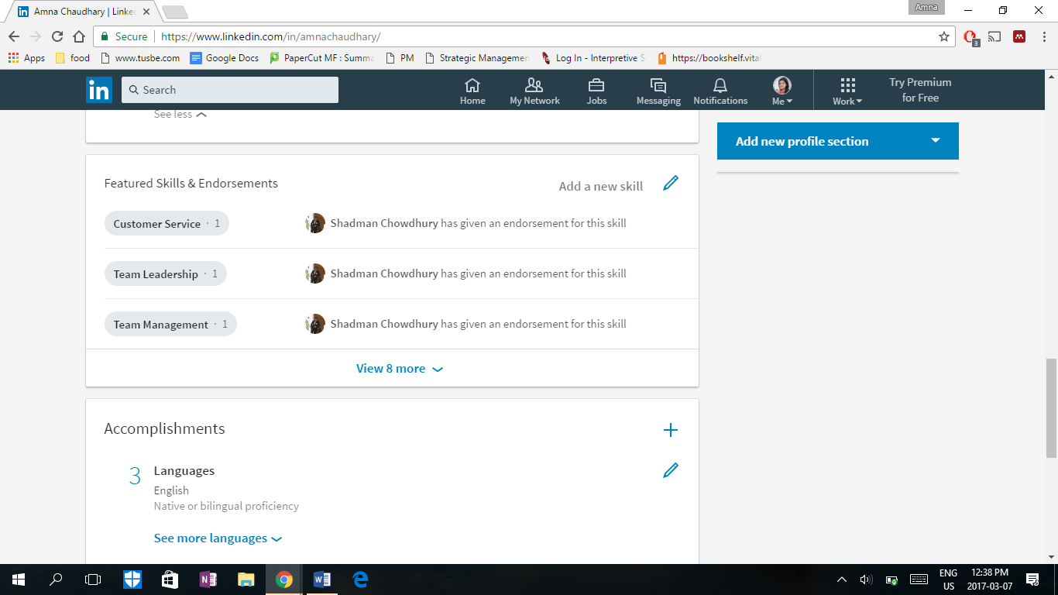
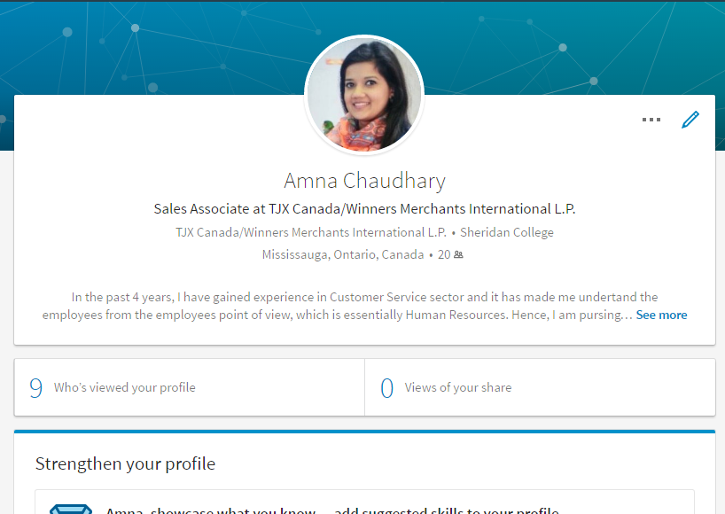
https://www.linkedin.com/in/amnachaudhary/
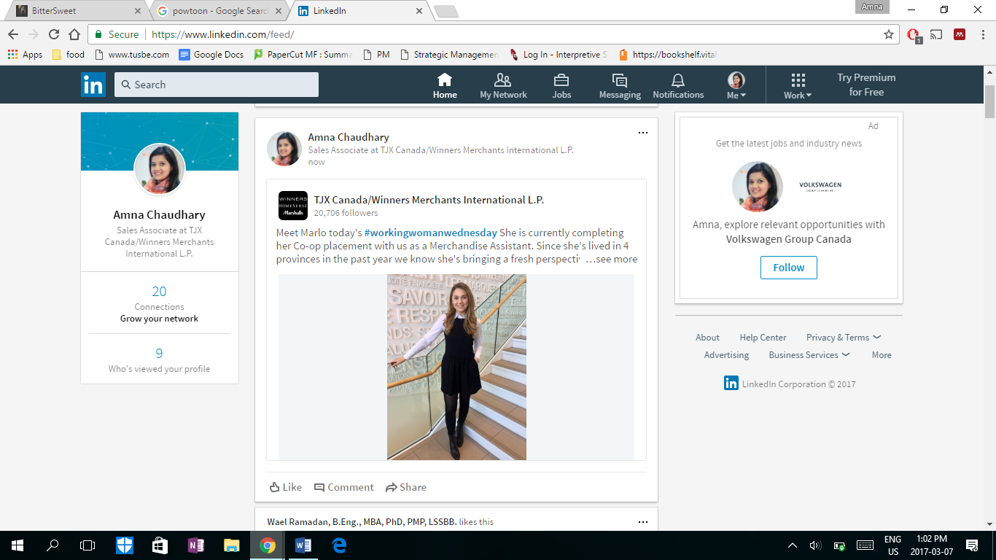
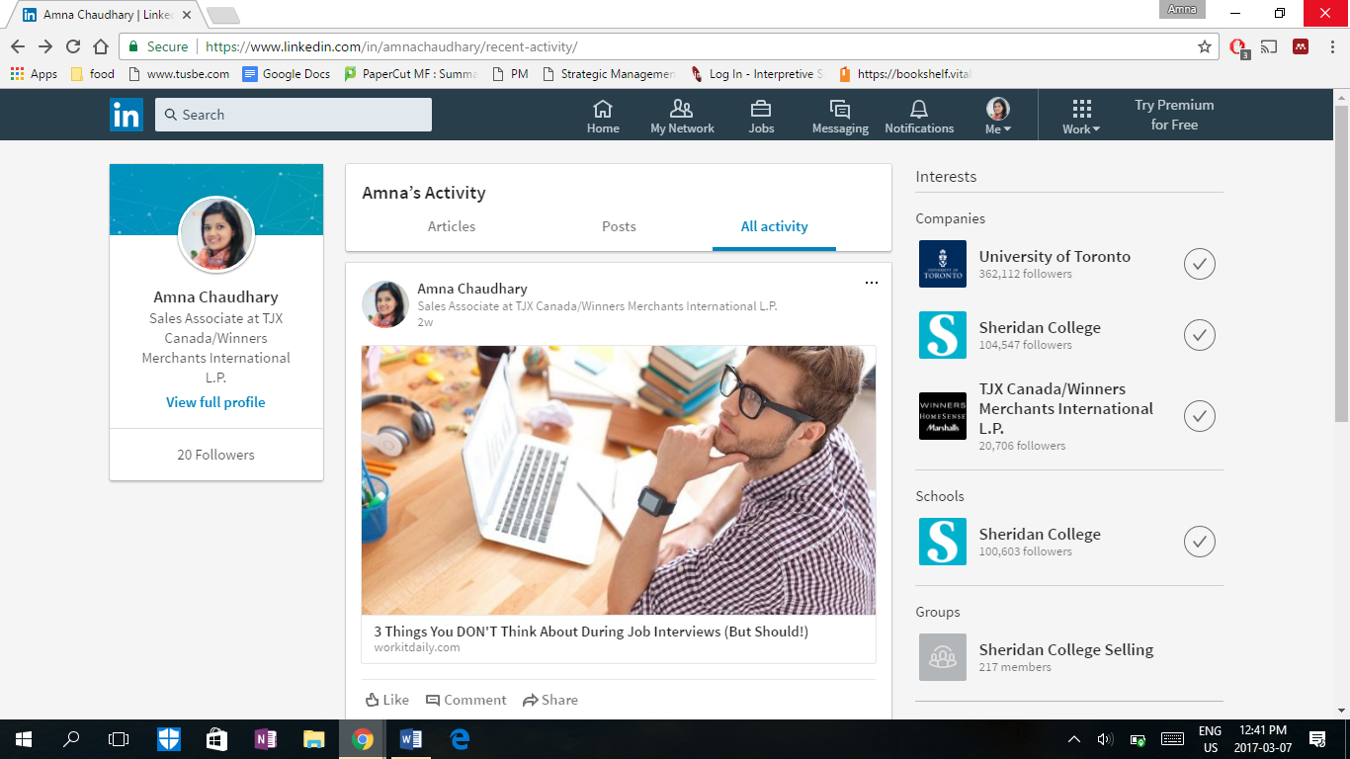
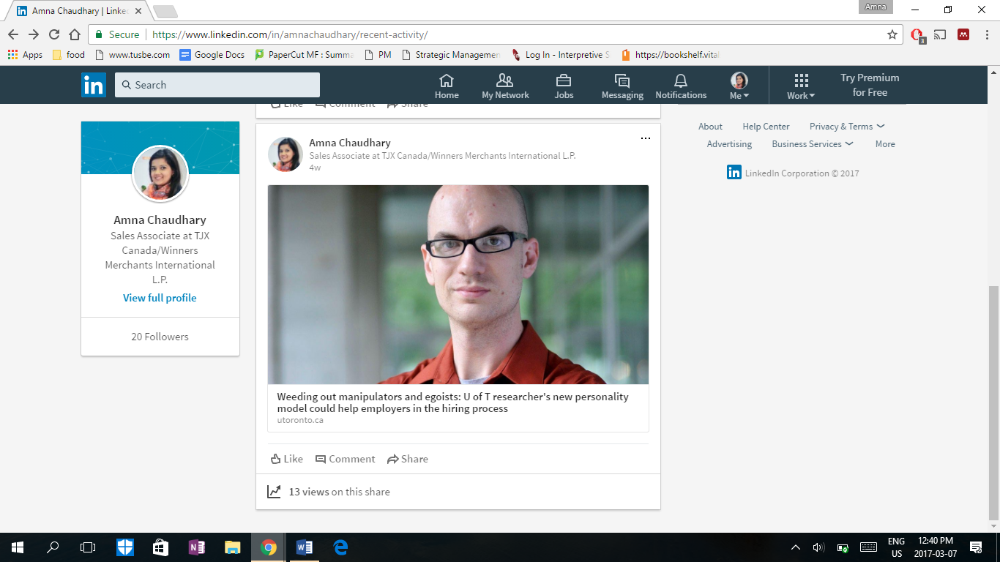
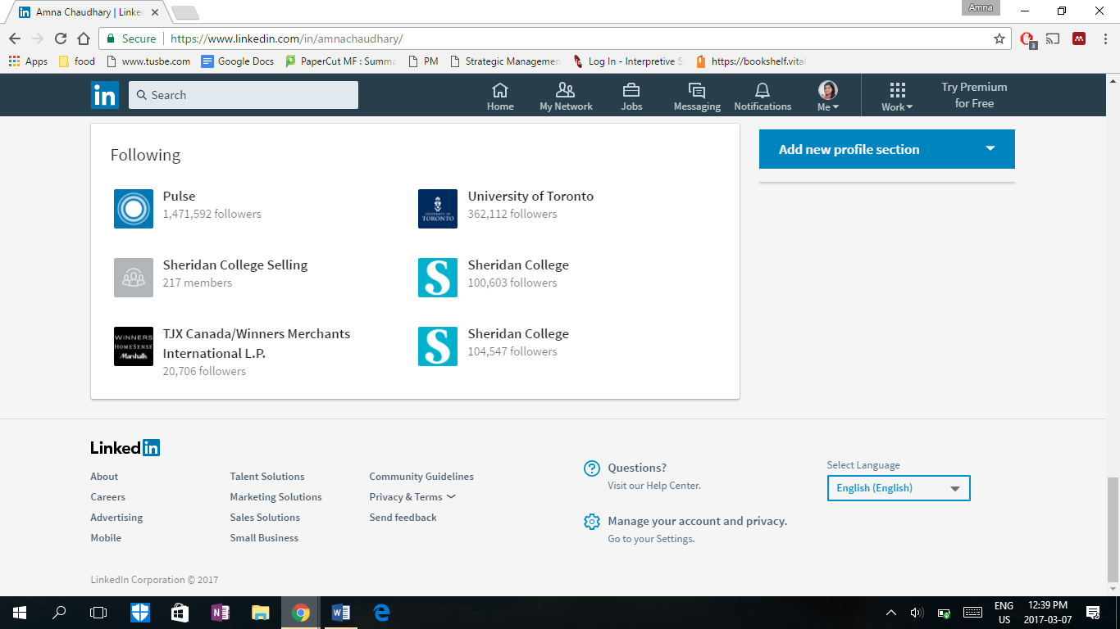
FACEBOOK
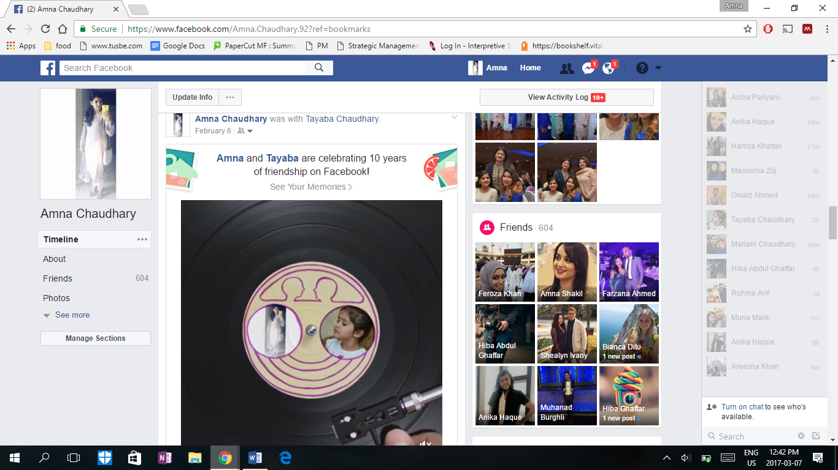
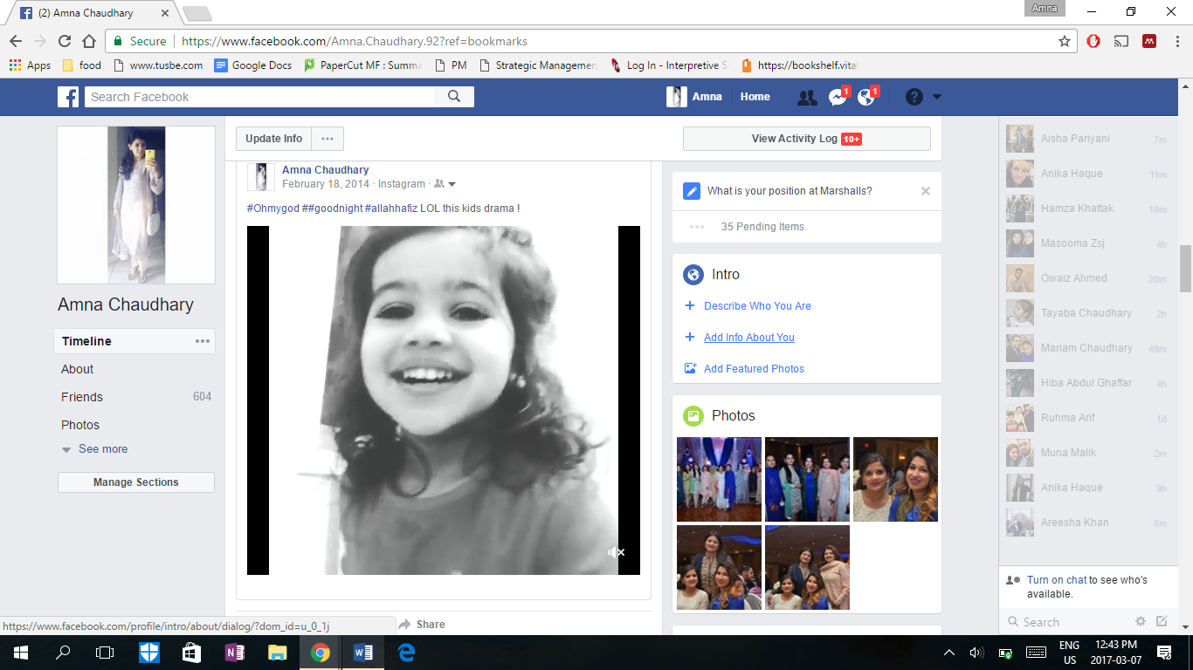
https://www.facebook.com/Amna.Chaudhary.92
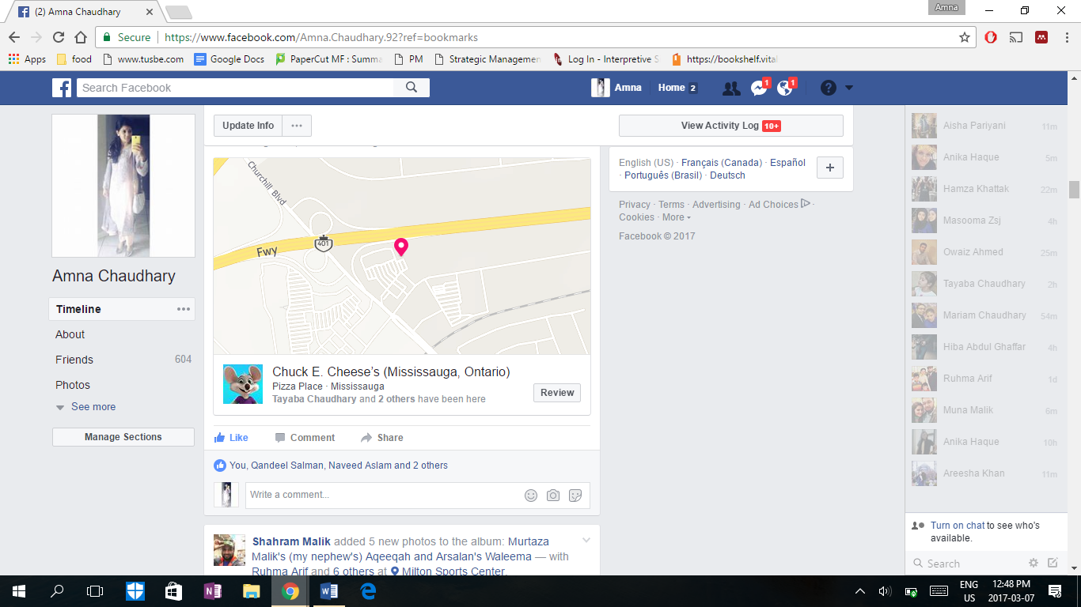
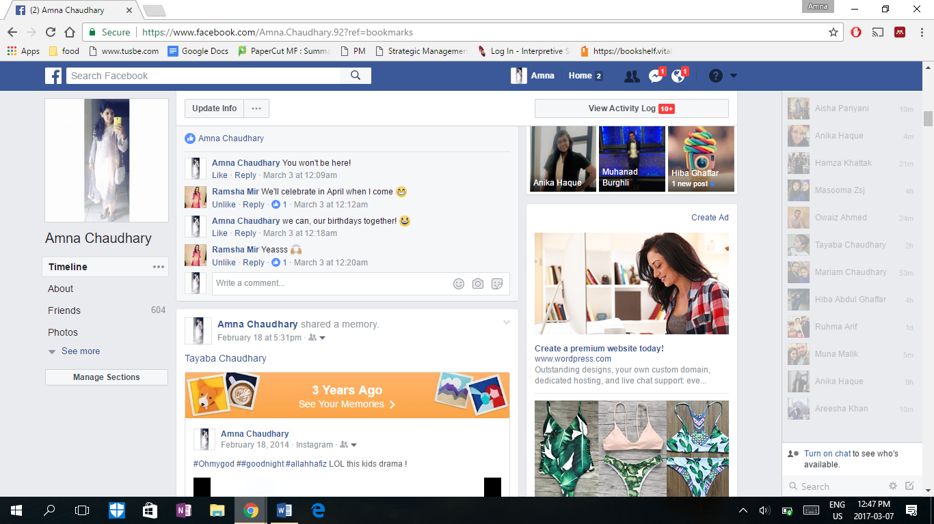

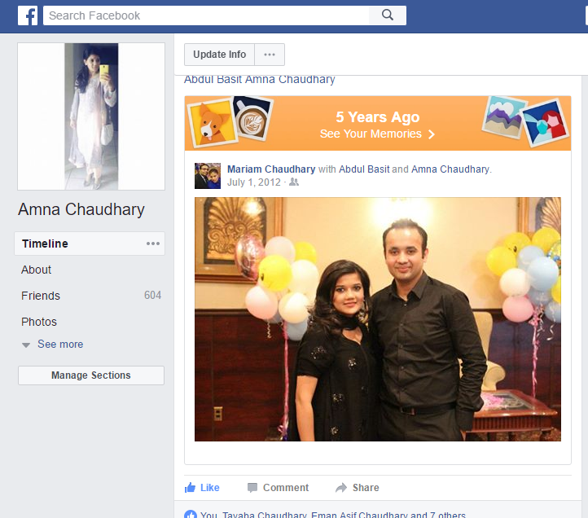
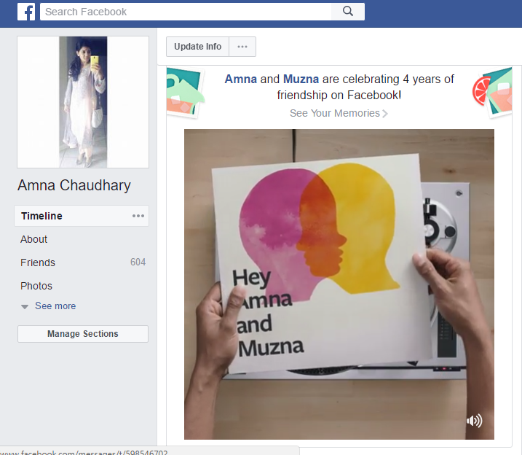

TUMBLR
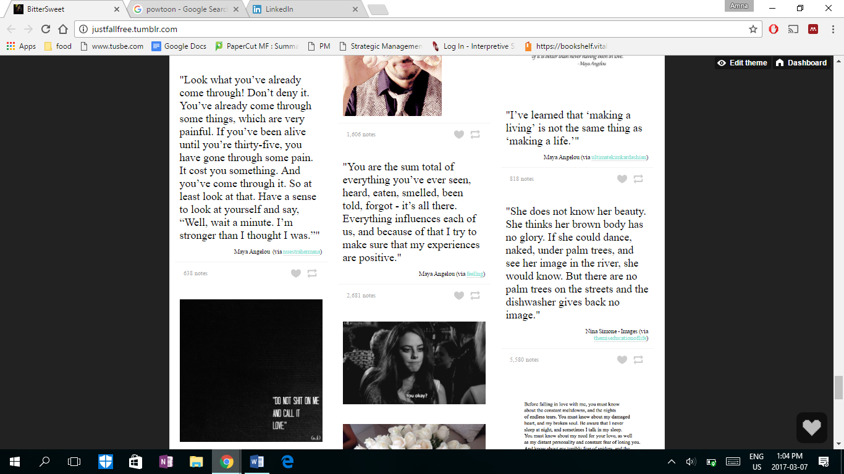
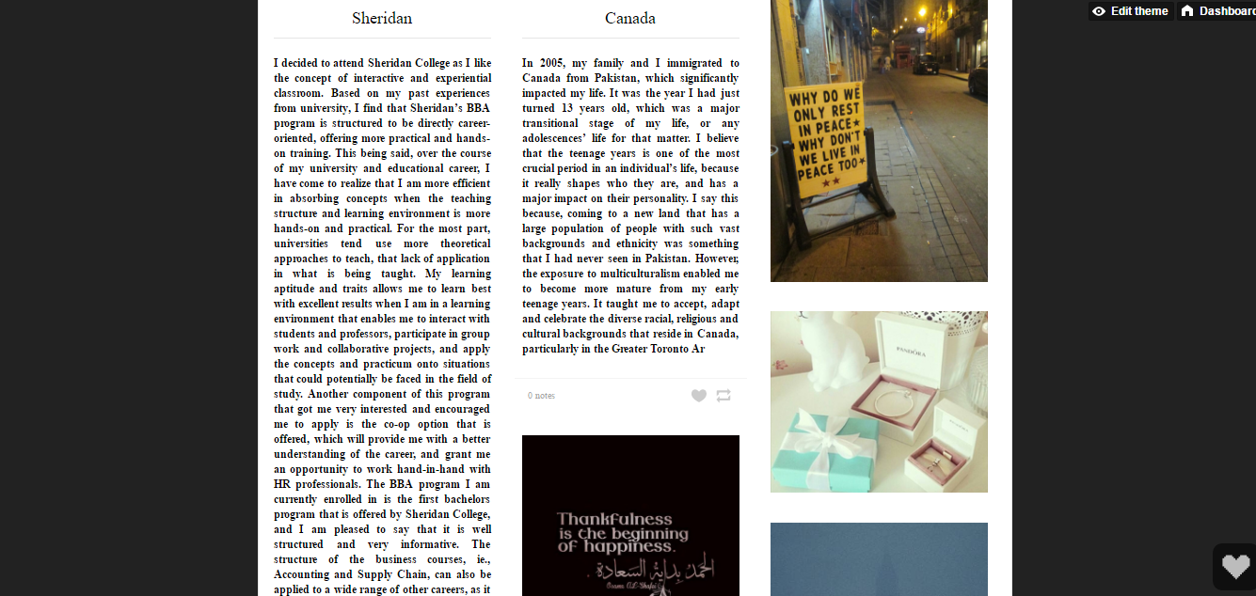
http://justfallfree.tumblr.com/

PINTEREST
https://www.pinterest.com/ChAmna/
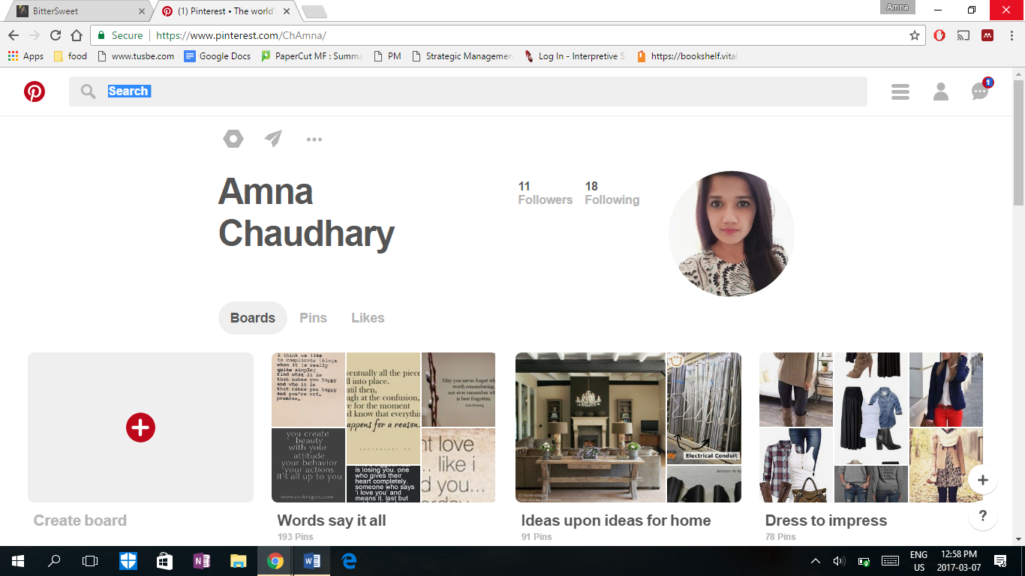

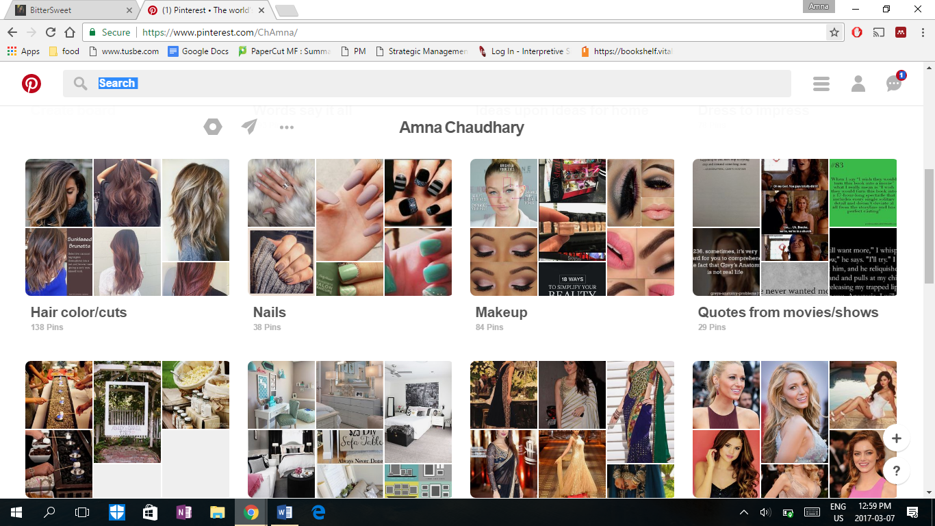

PERSONAL BRANDING VIDEO
https://www.youtube.com/watch?v=-3HFE4fmzys&rel=0

Bibliography

Prodromou, T. (2015, March 31). The Two Strategies for Networking on LinkedIn -- And Why They Matter. Retrieved from Entrepreneur: https://www.entrepreneur.com/article/242721
Talent Egg. (2016, July 14). Retrieved from TJX Canada/Winners Merchants International, L.P. Merchandise Assistant: http://talentegg.ca/employer/tjx-canada-winners-merchants-international--l-p-/jobs/merchandise-assistant-26
Talent Egg. (2017). Retrieved from TJX Canada/Winners Merchants International, L.P.: http://talentegg.ca/employer/tjx-canada-winners-merchants-international--l-p-/jobs/hr-administrator-1
TJX Company. (2016). Retrieved from About Us Menu: http://www.tjx.com/about/tjx_company.html

